**Project Documentation and Report**

**LONG TERM INTERNSHIP ON SALESFORCE**

**Faculty Mentor: K. Anjaneyulu**

**Team ID: LTVIP2023TMID08741**

**Team Size: 5**

**Team Lead: C Pallavi**

**Team Members: Thunga Aswini**

**Reddipalli Sohail**

**Yelarathi Bhavana**

**Kotramangalam Teja Krishna**

**CREATION OF AN APPLICATION FOR SCHOOL MANAGEMENT**

**INTRODUCTION:**

**Overview:**

**A school management application is a software application that is designed to streamline various administrative tasks within a school. This system is designed to automate a range of processes such as student enrolment, course scheduling, fee management, library management, attendance tracking, and more. The goal of a school management application is to simplify these processes and make them more efficient, saving time and reducing errors.The school management application connects schools and parents directly. It informs the parents about their children’s development and learning progress without having to wait until the end of the semester or the occasional parents’ conference**

**Purpose:**

**The purpose of the project is to manage the school in the proper way The School management application provides real-time knowledge for all the students who have basic knowledge of Salesforce and Looking for a real-time project. This project will also help those professionals who are in cross-technology and want to switch to Salesforce. With the help of this project they will gain knowledge and can include it into their resume as well.This school management application allows to create student schedules to which you can add subjects, assignments, etc. It will enable communication between students, teachers, and parents. It provides a mobile app where students, teachers, and parents can access students’ attendance, grades, etc. It provides security and keeps your data safe.**

**LITERATURE SURVEY:**

**With school management software, teachers, parents, and administrators have easy access to important information such as student records, academic performance, and attendance records. This makes it easier to monitor student progress and identify areas where improvement is needed**

**THEROTICAL ANALYSIS:**

**Block Diagram : Diagrammatic View of the Project:-**

**[Creation Of An Application For School Management]**

**Introduction : Creating Salesforce Org**

**⬇️**

**Object : 1.Creation of school object**

**2.Creation of student object**

**3.creation of parent object**

**⬇️**

**Lightening App :Creation of School management app**

**⬇️**

**Fields and Relationship: 1.Creation of fields for School object**

**2.Creation of fields for Student object**

**3.Creation of fields for parent object**

**⬇️**

**Profile: Creation of profile**

**⬇️**

**Users:Creation of users**

**⬇️**

**Permission sets : 1.permission set 1**

**2.permission set 2**

**⬇️**

**User adoption : 1.Create record (school)**

**2.View record (school)**

**3.Delete record (school)**

**⬇️**

**Reports :1.Create reports**

**2.view reports**

**Creating Developer Org:**

**We have created a Salesforce Developer Org and Activated the Account**

**Salesforce Developer Signup link:https://developer.salesforce.com/signup**

**Salesforce Login link:https://login.salesforce.com/?locale=in**

**We got the mails for account verification**

**After account verification we logged into Salesforce account**

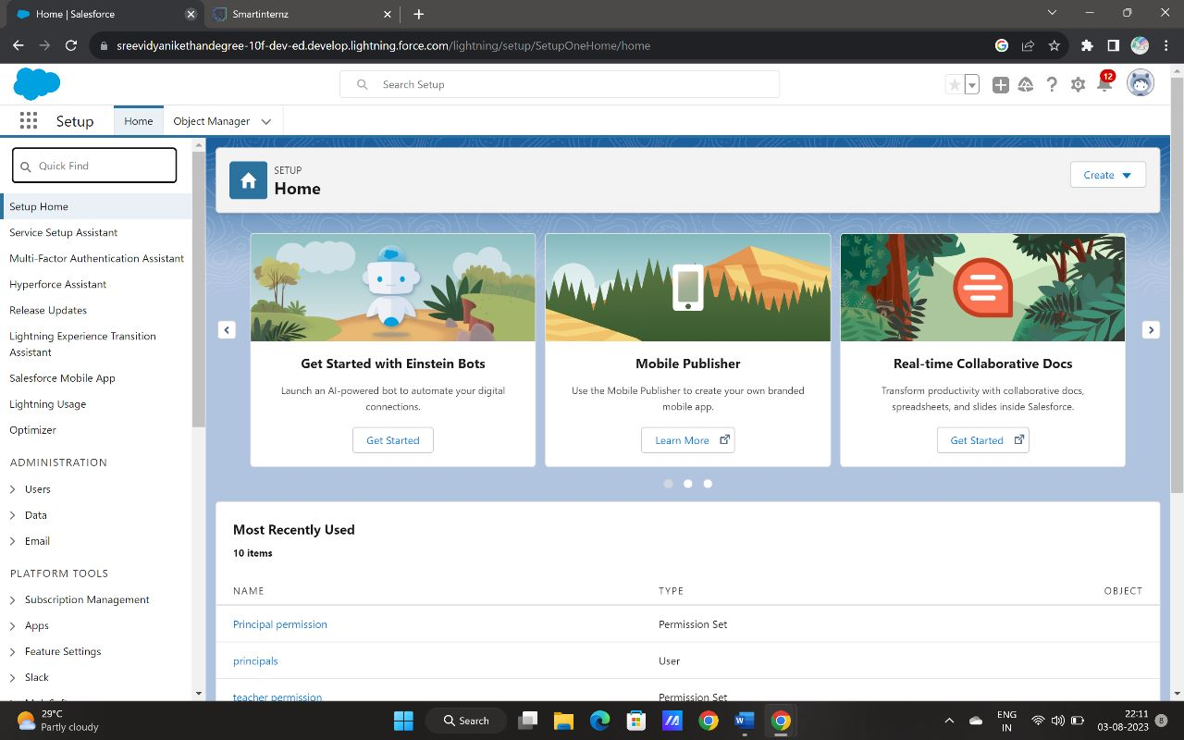 **Object:**

**We have created school object for school management application ,similarly we have created 2 more objects such as student and parent object**

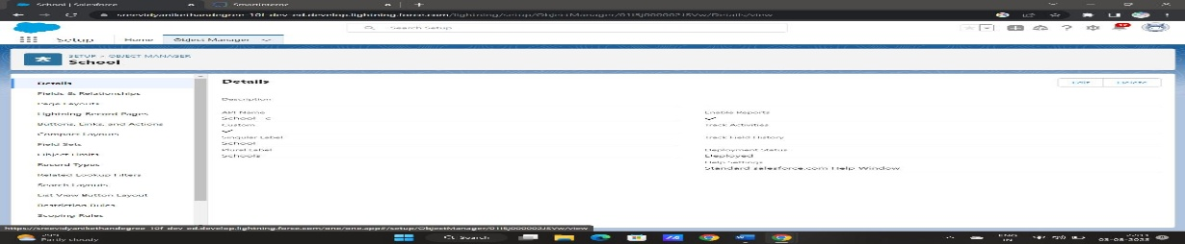

**Lightening App:**

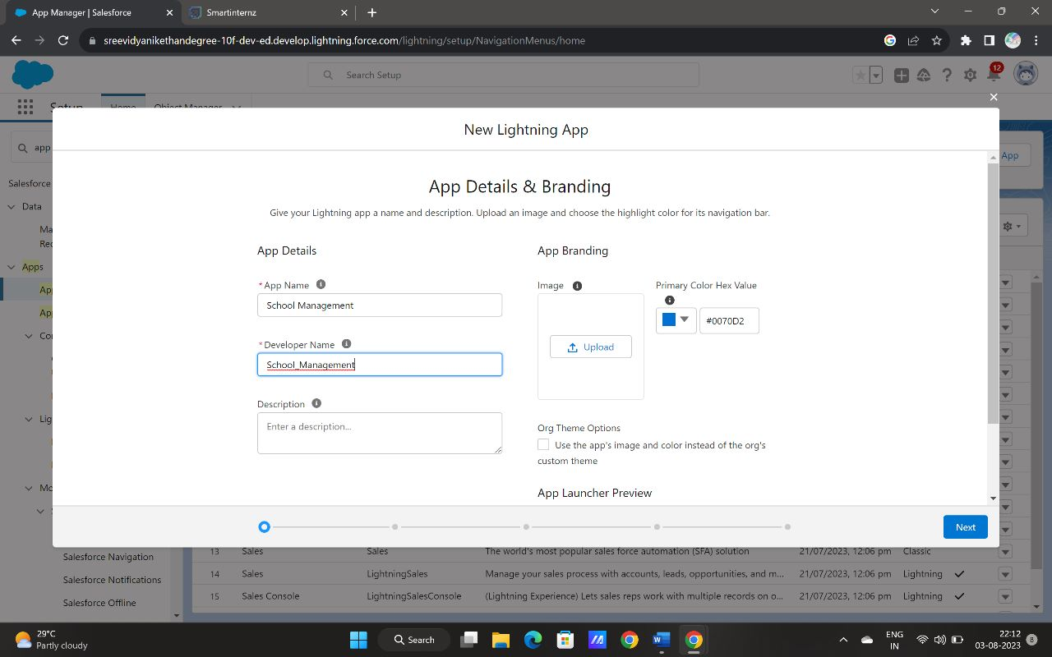 **We have created a School management app**

**Fields and Relationship:**

**We have created fields for the school objects . In the same way we have created fields for student and parent objects.**

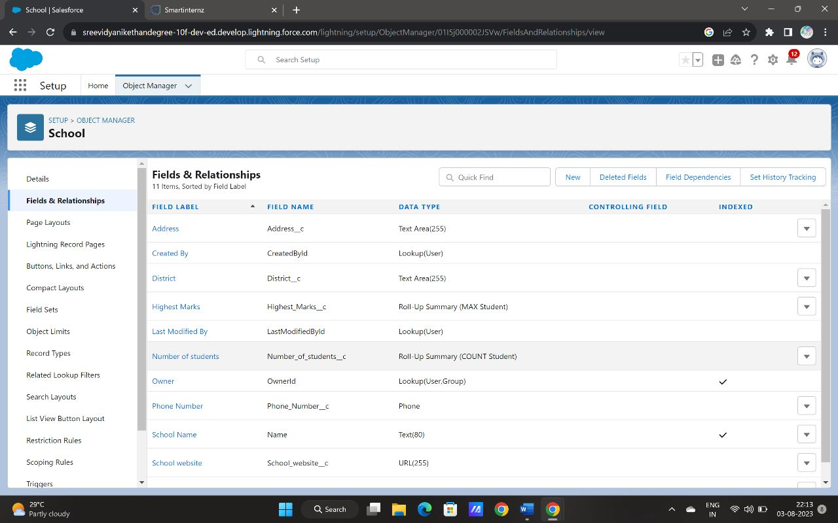

**Profile:**

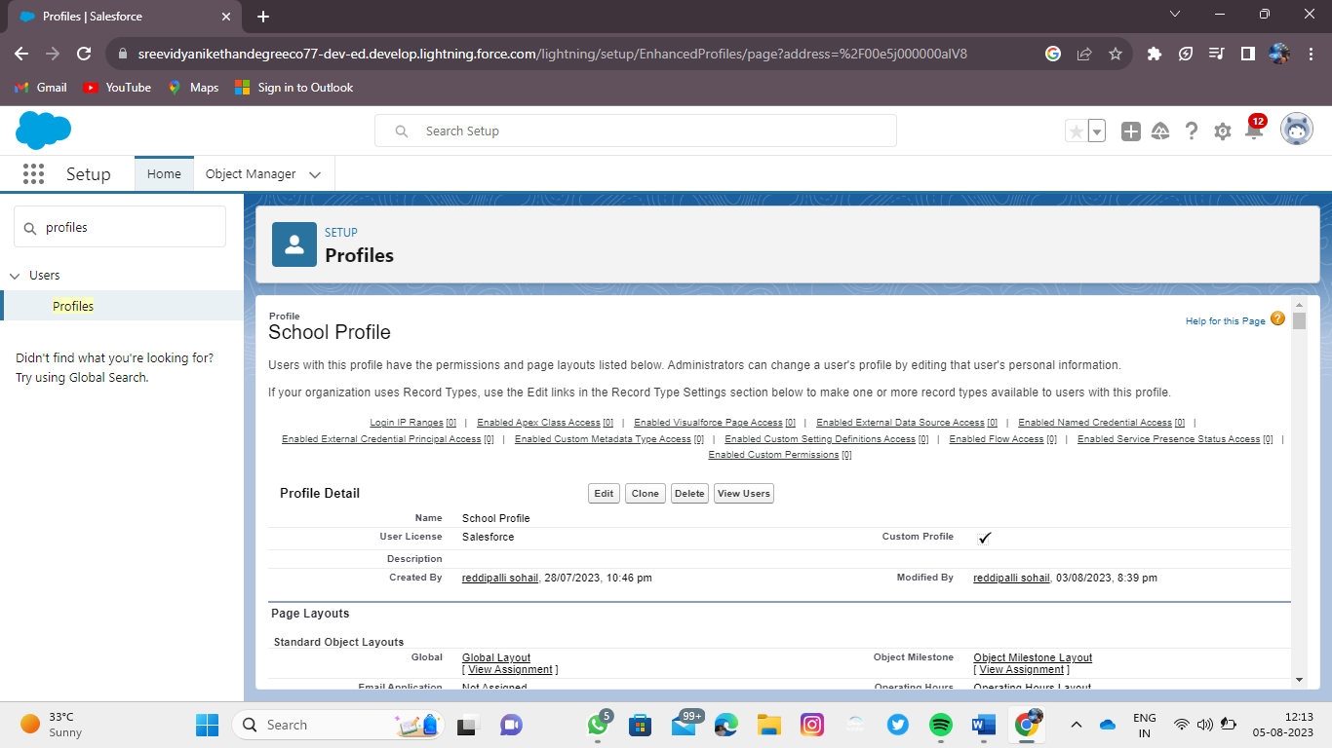 **We have created the clone profile for standard user profile which is named as School Profile**

**Users:**

**We have created the 3 users named as parents , Teachers and Principals under school profile with Salesforce License**

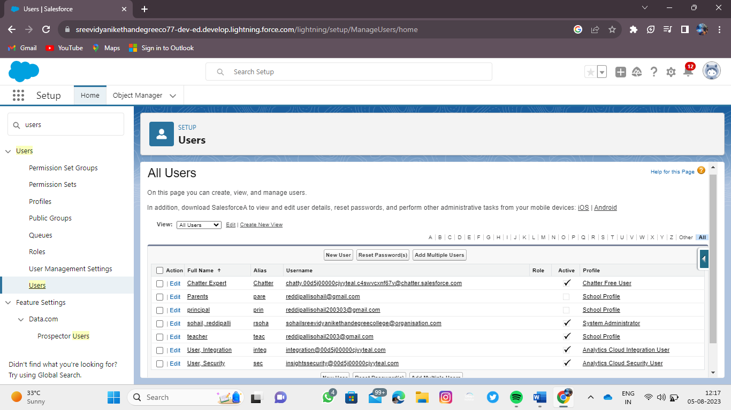

**Permission sets:**

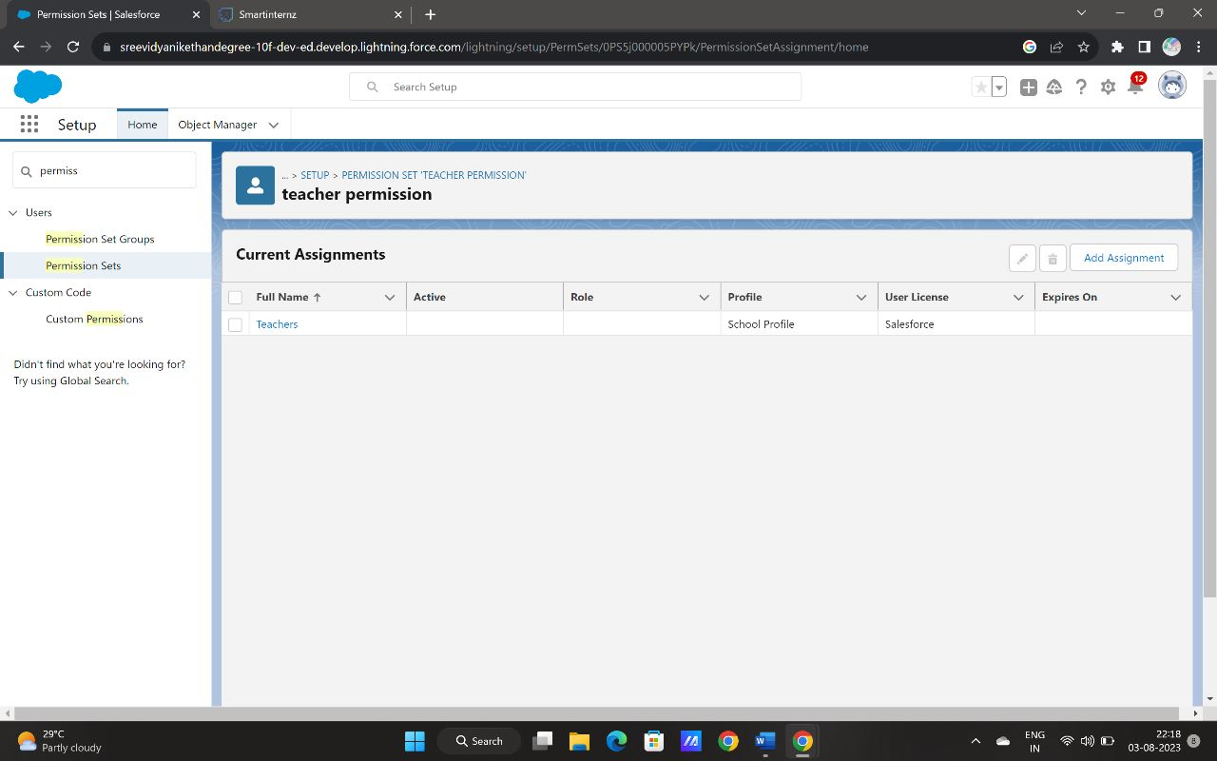 **We have created permission set named as Teacher permission And we allow the view, create and edit permissions to all the 3 custom objects such as school, student and parent objects and assign the teacher user to teacher permission**

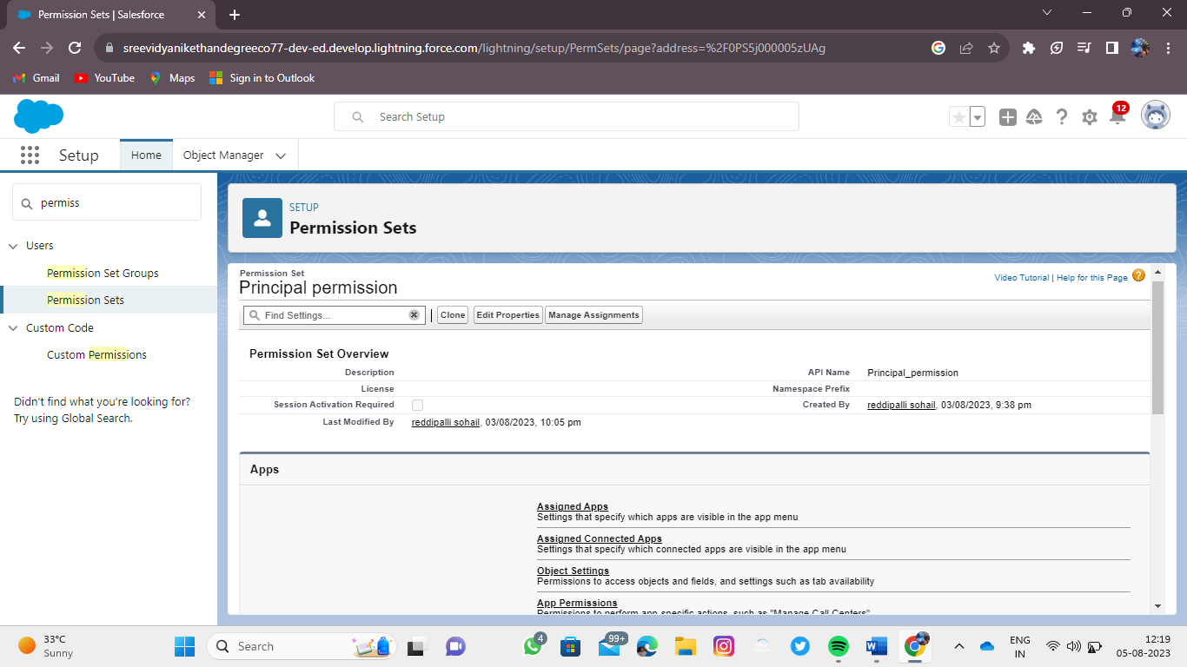 **Similarly ,We have created permission set named as Principal permission And we allow all the permissions to all the 3 custom objects such as school, student and parent objects and assign the principal user to prinicipal permission**

**User Adoption:**

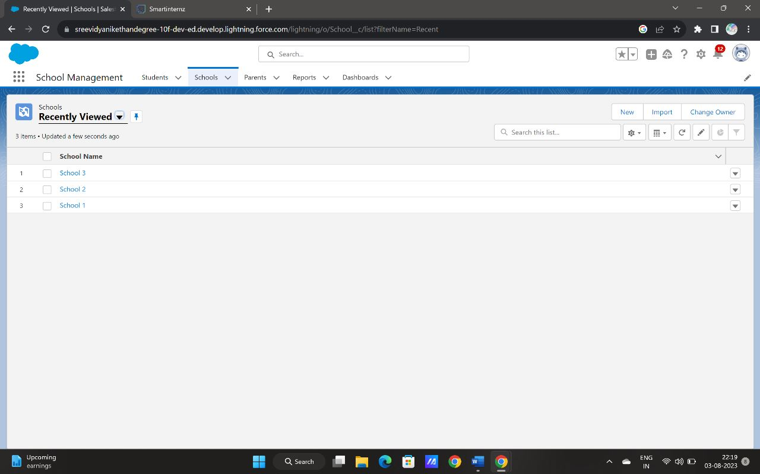**We have created the 4 school records and viewed all the records and deleted the one particular record**

**Reports:**

**Finally we have created the reports which is named as Schools with student reports**

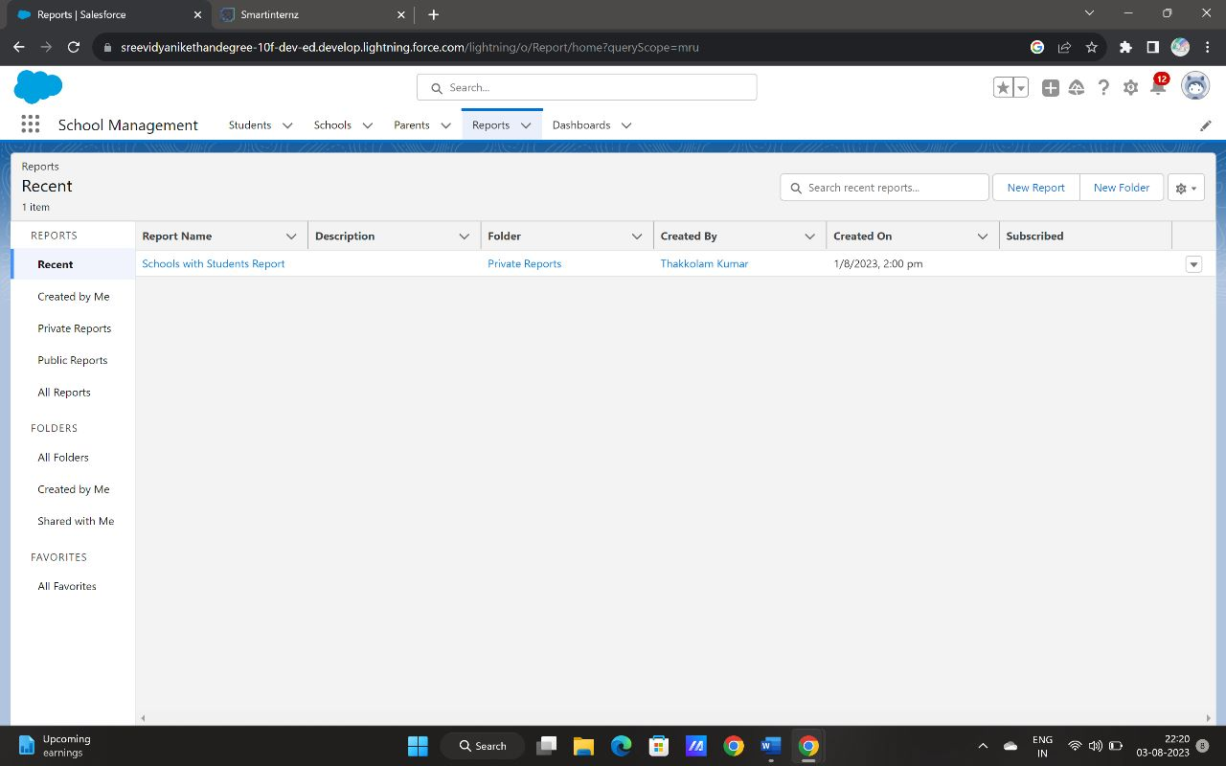

**Results:**

** Records : we have created the school records which is shown in the below picture**

**Reports: we have created the reports which is shown in the below picture**

**Advantages:**

* **Makes the Admission Management Process easier**
* **Easy to track the fee status, assignments, exam results, grades, parent info within seconds**
* **It helps to give the feedback**
* **Easy for attendance and hostels management**
* **Quick Access to Every Information**
* **Better Student Data Management**

**Disadvantages:**

* **The school management application is not user-friendly – it can be difficult for teachers and administrators to use if the software is not well designed with the latest UI parameter**
* **If the school management application is not affordable, then it can be a financial burden for Schools**
* **The school management application does not have enough features to fulfill the school’s rrequirement**

**Applications:**

* **Student enrolment**
* **Course scheduling**
* **Fee management**
* **Library management,**
* **Attendance tracking etc….**

**Conclusion:**

**School management Application can play a critical role in improving academic success. By streamlining administrative tasks, improving communication, and providing access to valuable data, these systems can help create a more supportive and effective learning environment for students.**

**Further scope:**

**A comprehensive student management system can ensure that faculty and staff get the right information at the right time. By increasing accessibility to data, educators are better equipped to accurately assess each individual student’s risk factors and take the necessary steps to prevent any negative outcomes.**